FREQUENTLY ASKED QUESTIONS

Xero Accounting Financial Integration

Last Revised: May 27, 2022
FAQs
About Xero 1
1. In what countries is Xero Accounting integration with SAP Concur supported? 1
2. Which Xero Accounting plans does the Xero Accounting connector support? 1
3. What if I need to make changes to master data in Xero Accounting, for example, deleting an account? 1
4. Can I connect multiple Xero company files to one Concur account? 1
Accounts 1
5. How do I refresh accounts from Xero Accounting to SAP Concur? 1
6. What account types are supported by the integration? 2
7. Are journal entry postings supported with the Xero Accounting integration? 2
8. When I try to post CC transactions to Xero Credit Card account, I receive the following error: "Posting Failed. AIS-POST-ERROR: Error Posting. The system was unable to process the document. Financial Posting Failed. The Bank Account code in ERP is missing." How do I resolve the error? 2
Custom Fields 3
9. Does SAP Concur support tracking categories? 3
10. How do I refresh Cost Objects between Xero Accounting and SAP Concur? 3
11. Can I use one of my tracking category's custom fields to drive my alternate account codes? 3
Contacts/Vendors 3
12. How do I add users from Xero Accounting into SAP Concur? 3
13. How do I distinguish employee contacts (vendors) from accounts contacts (vendors) in Xero Accounting? 3
14. How do I refresh employee vendor data from Xero Accounting? 3
15. How do I refresh account vendor data from Xero Accounting? 3
Products and Services/Item Codes 4
16. Will Xero Accounting item codes (Products and Services) integrate into SAP Concur? 4
Tax Codes 4
17. Does the integration support VAT/GST tax codes? 4
18. Does the integration support FBT (Fringe Benefits Tax)? 4
19. How do I refresh tax codes from Xero Accounting? 4
Posting Bills and Credit Card Transactions to Xero Accounting 5
20. Can I post a credit card transaction as a bill or to my credit card bank account? 5
21. What happens if a claim for a month (for example, February) contains transactions from a previous month (for example, January) and the previous month end (January Month End) is closed in Xero Accounting? 5
22. How will out of pocket expense transactions post to Xero Accounting? 5
23. How will AP invoices post to Xero Accounting? 5
24. When a credit card transaction posts as a bill, on what date will it post? 5
25. If I am using Concur Pay to reimburse my employees, will SAP Concur close out the bills that post to Xero? 6
26. Does the Xero Accounting integration support multi-currency posting? 6
Connecting and Disconnecting 6
27. How can I confirm that I have connected Xero Accounting to SAP Concur? 6
28. What happens if I need to disconnect from Xero Accounting? 6
29. What if I accidentally connect to the wrong Xero Accounting realm? 7

About Xero

In what countries is Xero Accounting integration with SAP Concur supported?
- US
- UK
- AU
- NZ
- SG
The Xero connector does not support multicurrency transactions. All transactions from SAP Concur will post to Xero in the home currency of Xero.

Which Xero Accounting plans does the Xero Accounting connector support?
- US: Growing and Established
- UK, AU, NZ: Standard and Premium

What if I need to make changes to master data in Xero Accounting, for example, deleting an account?
Prior to making changes to master data, the administrator should notify users to stop submitting expense reports and/or invoices and wait for all the submitted reports and invoices to finish the approval process. Then the administrator can then make the change in Xero Accounting and update the synchronized data in SAP Concur. Once all changes have been synchronized, the users can start creating and submitting reports and invoices again.

Can I connect multiple Xero company files to one Concur account?
No. The SAP Concur integration is a 1:1 ratio. You can connect one Xero Accounting company file to one SAP Concur account.

Accounts

How do I refresh accounts from Xero Accounting to SAP Concur?
Account data is cached and will update every hour. If a user searches for a new or updated account when the cache is still stale, they will not find the account in the SAP Concur system. The SAP Concur administrator can manually invoke a refresh by clicking the “refresh” button in the My Xero Data window.

What account types are supported by the integration?
For mapping expense types in Expense and/or Invoice:
- Overheads
- Expenses
- Direct Costs
- Overhead
- Current Assets
- Other Current Assets
- Fixed Assets
For mapping credit card accounts:
- Credit Card Bank Accounts
For mapping liability accounts:
- Current Liability
For mapping clearing account codes:
- Current Assets

Are journal entry postings supported with the Xero Accounting integration?
No. General journal entry postings are not supported.

When I try to post CC transactions to Xero Credit Card account, I receive the following error: "Posting Failed. AIS-POST-ERROR: Error Posting. The system was unable to process the document. Financial Posting Failed. The Bank Account code in ERP is missing."
How do I resolve the error?
When posting to Xero Accounting, all accounts must have an account code in Xero. In Xero, confirm that your credit card bank account has an account number.
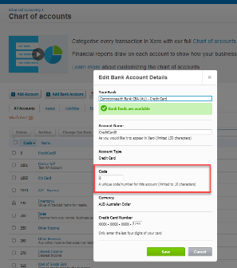

Custom Fields

Does SAP Concur support tracking categories?
Yes. You can select two tracking categories (cost tracking objects). SAP Concur will only pull in active tracking categories.

How do I refresh Cost Objects between Xero Accounting and SAP Concur?
After tracking categories are added in Xero Accounting, within one hour they appear on the Manage Custom Fields page.

Can I use one of my tracking category's custom fields to drive my alternate account codes?
No. You must create a new custom field in SAP Concur solutions to drive your alternate account codes. You cannot use an external list to define your alternate account code structure.

Contacts/Vendors

How do I add users from Xero Accounting into SAP Concur?
Clients typically set up their employees as contacts (vendors) in Xero Accounting. Contacts must be added to Xero Accounting with first name, last name, and email address.

How do I distinguish employee contacts (vendors) from accounts contacts (vendors) in Xero Accounting?
Xero Accounting does not provide a definitive way to distinguish employee contacts (vendors) from accounts contacts (vendors). There is no flag or attribute to differentiate these contacts. SAP Concur filters contacts based on the presence of an email address. If an email address exists within the supplier (vendor) record, SAP Concur presents the contact as an employee supplier (vendor).

How do I refresh employee vendor data from Xero Accounting?
- Employee contact (vendor) data refreshes when you click the Add Users from Xero Accounting button on the Users page.
- When you click the Add Users from Xero Accounting, the information is refreshed immediately. There is no delay.

How do I refresh account vendor data from Xero Accounting?
- When you click the Add Vendors from ERP button on the Manage Vendors page, the account vendor data is refreshed.
- When you click the Add Vendors from ERP button, the information is refreshed immediately. There is no delay.

Products and Services/Item Codes

Will Xero Accounting item codes (Products and Services) integrate into SAP Concur?
Yes. SAP Concur integrates with item codes (Products and Services).

Tax Codes

Does the integration support VAT/GST tax codes?
- Yes. Upon connection, SAP Concur will pull VAT/GST tax codes from Xero Accounting.
- Clients have two options to post with VAT/GST.

Does the integration support FBT (Fringe Benefits Tax)?
- While SAP Concur integration supports tracking FBT, the integration does not support FBT.
When FBT is enabled, it causes issues posting data when attendees are added to a line item. The account code and reclaim code override the mapped account code and reclaim code. You will need to add the same account code and tax code to the FBT page.0
There are 2 options for customers pertaining to FBT:
- Option 1: Disable FBT or remove all FBT data.
- To remove FBT data, click on a line item in Taxation > Fringe benefits and then click Remove.
- Option 2: Add the Xero account code and the tax code to each FBT line item. Adding these codes to each FBT line item ensures that the mapped expense types and reclaim codes match the FBT line items.
- The Xero account code can be found in the Xero chart of accounts.
- The tax code can be found on the Taxation page in Product Settings.

How do I refresh tax codes from Xero Accounting?
- Tax code data is refreshed when a tax group is double-clicked, and the tax modal appears.
- When a tax group is double-clicked, the information is refreshed immediately. There is no delay.

Posting Bills and Credit Card Transactions to Xero Accounting

Can I post a credit card transaction as a bill or to my credit card bank account?
Yes. Clients have the option of posting transactions as a bill to the credit card vendor name or to the credit card bank account.

What happens if a claim for a month (for example, February) contains transactions from a previous month (for example, January) and the previous month end (January Month End) is closed in Xero Accounting?
If a claim contains transactions from a month end that is closed, those transactions will not be posted to Xero Accounting. However, clients can post credit card transactions to the credit card bank account or as a bill to the credit card vendor name. When posting bills, SAP Concur posts according to bill posting preferences.

How will out of pocket expense transactions post to Xero Accounting?
They will post as a bill.

How will AP invoices post to Xero Accounting?
They will post as a bill.
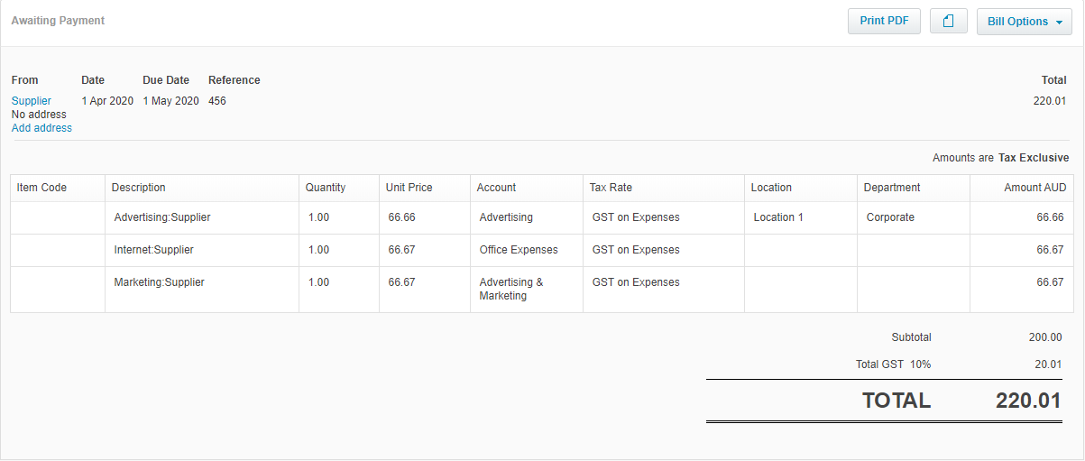

When a credit card transaction posts as a bill, on what date will it post?
The transaction date that will post is based on the bill posting preferences that are configured in SAP Concur.
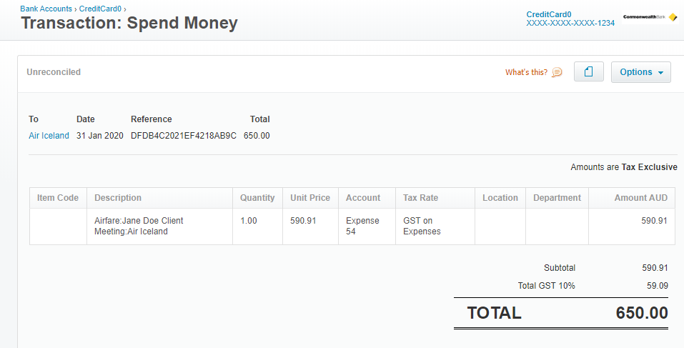

If I am using Concur Pay to reimburse my employees, will SAP Concur close out the bills that post to Xero?
No. When using Concur Pay, bills will still post to Xero. These must be manually closed out.

Does the Xero Accounting integration support multi-currency posting?
No. When using the SAP Concur Xero Accounting integration, we do not look at currency and will post the home currency of Xero. If the home currency in Xero is AUD, then that is the currency in which transactions will post.

Connecting and Disconnecting

How can I confirm that I have connected Xero Accounting to SAP Concur?
In SAP Concur, on the Accounting page in Product Settings, Xero appears in the Select your accounting software field and the name of the Xero Accounting realm to which SAP Concur is connected is displayed below the field.

What happens if I need to disconnect from Xero Accounting?
- Clients cannot disconnect from their accounting software if any expense reports or invoices are in-flight. This includes expense reports and invoices that have been created but have not yet been submitted.
- On the Accounting page in Product Settings, when an administrator clicks Disconnect from Financial System, if there are in-flight expense reports or invoices a warning page appears. The warning page displays a list of the inflight expense reports and/or invoices.
- The in-flight expense reports and invoices must either be processed or recalled and deleted.
- If there are no in-flight expense reports or invoices, the system can be disconnected.

What if I accidentally connect to the wrong Xero Accounting realm?
- Process or delete any in-flight expense reports or invoices and ensure that users cannot create any new expense reports or invoices.
- Disconnect the financial system.
- Connect to the correct financial system and begin remapping your configuration.

